Centenarian Conservationist Helped Protect Bay of Fundy Wetlands

Lifelong love of nature led to wetland conservation in New Brunswick, Canada

By Jessica Shea

“I wouldn’t want to live in the city because I’m too free a creature,” said Mabel Fitz-Randolph in an interview with the Nature Conservancy of Canada in 2010. At 97, the nature-loving New Brunswick native had been a lifelong resident of the Musquash Estuary on the Bay of Fundy. Fitz-Randolph passed in 2013, at 100 years old, leaving behind a legacy of conservation work.

For ten years, Fitz-Randolph helped campaign the Canadian government to designate a marine protected area in the Bay of Fundy; the area was designated in 2006. Three years later the centenarian entrusted 739 acres of land to the Nature Conservancy of Canada (NCC). Fitz-Randolph’s daughter and grandson donated another 80-acre parcel of the family's land in 2016.

Working with Ducks Unlimited Canada and using funding from the North American Wetlands Conservation Act, NCC has secured 5,500 acres of wetlands and associated habitat, including the Fitz-Randolph family’s donations, in the Musquash Estuary, which is the organization’s largest conservation area in Atlantic Canada.

NCC’s Paula Noel became friends with Fitz-Randolph through her years of work in the Musquash Estuary. “My best memories of Mabel are of stopping by her home when I was in the area,” Noel says. “She cared for a beautiful garden and her yard was filled with bird feeders. She loved the abundance of nature, and she told incredible stories. She knew everything about the history of the area and the people who lived there.” From the windows of Fitz-Randolph’s yellow wood-framed house she could look out on the bay and see seals and porpoises.

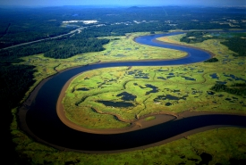
The Musquash Estuary was settled in the 1780’s by British Loyalists who relocated from the United States after the American Revolution. Fitz-Randolph’s husband, Albert, could trace his family lineage back to the Loyalists. The settlers diked the salt marshes to make hay fields and built homesteads in the area surrounding the Bay of Fundy. The population in Musquash Estuary peaked in the mid-1800’s. The area had sawmills and cotton mills, a meat factory, and several hotels. A series of natural disasters in the early 1900’s pushed people to the city of Saint John, 20 kilometers northeast.

Fitz-Randolph was born in 1913. Throughout the course of her life she saw the Musquash Estuary slowly revert back to a more natural landscape. By the early 2000’s, the forests surrounding the estuary were regrowing after years of timber harvesting and many stands were approaching old growth conditions.

The Musquash Estuary is the last fully functioning estuary in the Bay of Fundy. Musquash Estuary’s extensive wetlands are therefore an important landscape feature along the Atlantic flyway, which is the most important route for migratory birds in Eastern North America. Waterfowl such as American wigeons and ring-necked ducks breed in the estuary, while birds like red-winged blackbirds and Wilson’s snipes use the impounded freshwater wetlands. Songbirds, such as black-throated green warblers and northern parulas, abound in the surrounding woods.

According to Noel, one of the best ways to experience the Musquash Estuary is to paddle a canoe or kayak down the Musquash River. “Paddling down the river you can see the coastline change,” Noel says. “You begin at the flat wide expanses of salt marshes. Then the river opens up into the vast tidal cove, which has a rugged rocky shore interspersed with pocket beaches.” The Bay of Fundy has the highest tides in the world. When the tide recedes there are kilometers of exposed mudflats.

Acquiring and conserving more than 5,500 acres in the Musquash Estuary relied in part on grants from the North American Wetlands Conservation Act (NAWCA), which has provided funding for wetland habitat preservation projects in the U.S., Canada, and Mexico since 1989. “When we began the process this type of conservation project was unprecedented in New Brunswick,” Noel explains. “The NAWCA grants were critical. We wouldn’t have been able to commit to such a big scale project without the support of the U.S. Fish and Wildlife Service.”

Over the past 30 years, NAWCA has grown into one of the most significant conservation programs in history. More than 3,000 NAWCA-funded projects have conserved 30 million acres of wetlands and related habitats. The projects span nearly every state, territory, and province in Canada, the U.S., and Mexico. The goal of the multi-billion dollar grant program is to guarantee waterfowl and other wetland-dependant species a diversity of habitats across the continent, from breeding to wintering grounds, in perpetuity.

NAWCA-funded projects across Canada, the U.S., and Mexico have improved birdwatching, hunting, fishing, and other outdoor recreation opportunities on public lands. Habitats conserved through NAWCA projects have far reaching impacts. For example, the conserved wetlands store water and recharge aquifers, which helps secure future water supplies. Healthy wetlands also improve water quality by removing phosphates, nitrogen, and pesticides. When wetlands are restored to their natural states, they help prevent soil erosion during floods.

In addition to the 5,500 acres protected by NCC, and the protection of the marine and subtidal habitats by the Government of Canada, another 1,200 acres of salt marsh and upland habitat surrounding the Musquash estuary have been protected by the Province of New Brunswick and Ducks Unlimited Canada.

“In New Brunswick there is an urgent need to protect coastal salt marsh habitat,” Noel says. “There is little policy protection for these types of habitats. I hope that in 30 years we expand the protected area around the Musquash as well as the undeveloped areas down the coastline because currently there is little undeveloped protected land on the bay.”

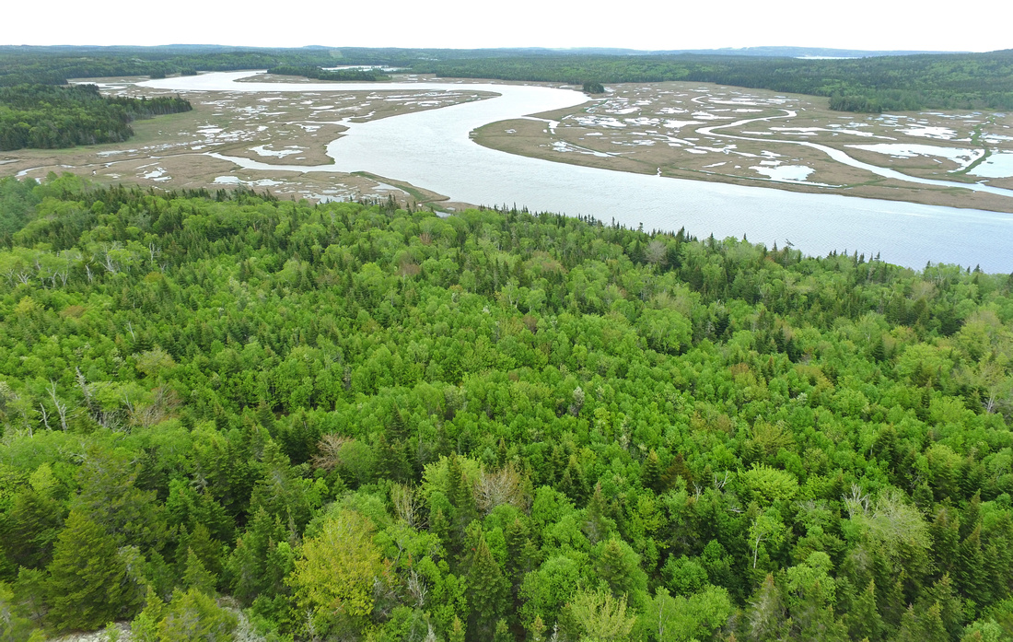
People enjoy the protected land in the estuary by hiking, canoeing, hunting, birdwatching, and spending time in nature. As Mabel Fitz-Randolph said in 2010 in an interview with NCC: “Oh, Musquash Estuary. Look at it today, upriver, downriver, cross river, and you’ll see that river just a-twinkling. It is beautiful.” The same holds true today.

