Waterfowl Phenomenon Sparks Passion for Wetlands on Alaskan Peninsula
A NAWCA funded project preserves 70,000 additional acres of Izembek National Wildlife Refuge Complex

By Jessica Shea

“I thought I saw a swirling cloud of smoke in the distance the first time I visited Izembek National Wildlife Refuge,” says Brad Meiklejohn, Alaska state director for The Conservation Fund. “I lifted my binoculars and realized it was thousands of birds.”

As the gyrating mass of birds approached, their beating wings sounded like an impending storm. Meiklejohn wondered, for a moment, if he would be sucked up into the tornado of birds like Dorothy in The Wizard of Oz.

“To see tens of thousands of birds, it felt like something primordial that I thought had vanished from the planet,” Meiklejohn says. Meiklejohn moved to Alaska from New Hampshire in the early 90’s because he wanted to live someplace unspoiled, a place where salmon still swim in rivers and bears still roam.

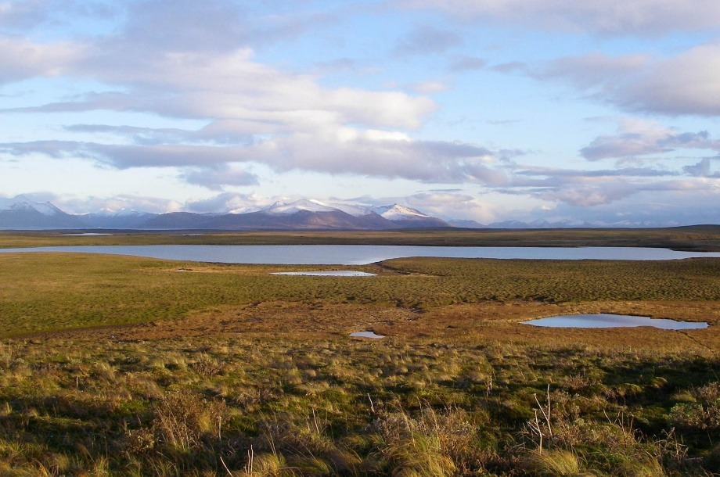
Though the bird encounter happened nearly 30 years ago, it remains one of the most powerful experiences of Meiklejohn’s life and became the catalyst for a decade of work leading to the preservation of 70,000 additional acres of Izembek.

Few places on earth are as alive with animals as Izembek National Wildlife Refuge Complex on the Alaskan peninsula. From caribou and brown bears to salmon and gray whales, Izembek teems with animals, not only in the air but on land and in water.
Izembek National Wildlife Refuge
Photo: USFWS

Izembek is a boon for birds—185 species of them. “Birds are the glue that holds the ecosystem together,” Meiklejohn says. “It’s as if the place were created for birds.”

Waterfowl are drawn to the area by the eelgrass that flourishes in the nutrient-rich Izembek Lagoon flanked by the Bering Sea and the Pacific Ocean. Every autumn upwards of a quarter of a million migratory birds feast on the caloric-rich eelgrass, many gaining the energy to sustain them for migrations spanning several thousand miles. Black brant migrate to Baja California, Mexico from Izembek and bar-tailed godwits head to New Zealand. Arctic terns fuel up at Izembek’s wetlands for the world’s longest migration from Alaska to the southern tip of South America.

In the early 90’s when Meiklejohn first visited Izembek, the area was only partially protected. “Looking at a map showed a Swiss cheese-like pattern in land ownership,” he explains. “Many of the holes represented privately owned land in need of preservation.” Private land scattered among parks and refuges leads to vulnerability in conservation lands.

Meiklejohn’s awe-inspiring first visit to Izembek captured his heart. He worked for ten years to protect as much land and wetlands as possible. The first step in the process was building relationships with landowners and fish and wildlife managers. “The key is to establish trust,” Meiklejohn says.
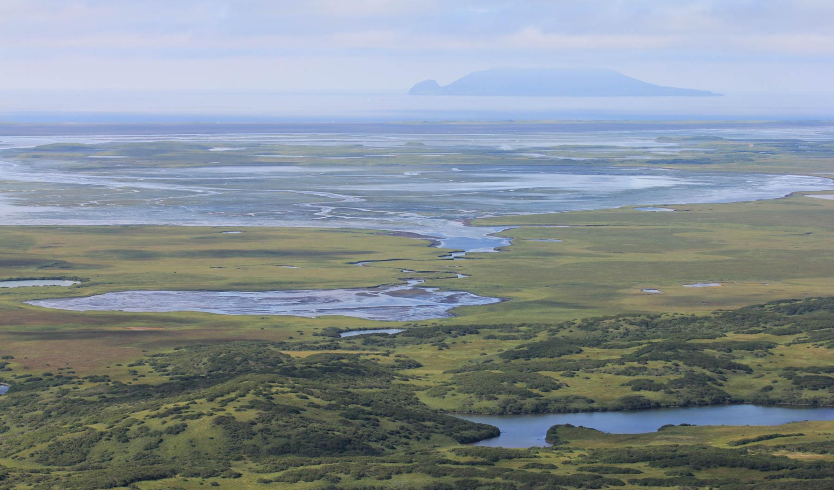
As refuge manager of Izembek in the mid-90’s, Greg Siekaniec spent years building relationships among stakeholders around Izembek. Landownership around Izembek includes Alaska native village corporations and the State of Alaska. “For villages that were considering selling,” Siekaniec explains, “a critical part of the discussion was not surrendering their cultural and traditional ties to their ancestral land.” By selling their land for inclusion in a National Wildlife Refuge, Alaska Native’s hunting and fishing opportunities were protected.
Izembek National Wildlife Refuge. Photo: USFWS

Establishing trust with tribes on the Alaskan peninsula took dedication. Siekaniec regularly traveled by small airplane or boat to attend council meetings with remote communities, some with just a few dozen members.

The next step in protecting Izembek was to extensively survey and study the wildlife in the area, especially the black brant and Steller’s eider. Meiklejohn, Siekaniec, and their team focused on those species as a way to secure funding to preserve land for all species at Izembek.

Siekaniec remembers visiting a remote village to give community members a synopsis of the coming field season based on the results of waterfowl and caribou surveys. “Community leaders said to me, ‘No one has ever done this before. We’re happy you’re telling us,’” Siekaniec says. When there was disagreement over wildlife survey results, Siekaniec invited those concerned with the accuracy of the information to join a survey, which helped build credibility.

Finding and developing relationships with funders was an equally crucial part of the process because private donations were matched with federal grants from the North American Wetlands Conservation Act (NAWCA), which has provided funding for wetland habitat preservation projects in the U.S., Canada, and Mexico since 1989. Waterfowl, and all Izembek’s native species, thrive today on the tens of thousands of acres preserved through donations and NAWCA grants.

Over the past 30 years, NAWCA has grown into one of the most significant conservation programs in history. More than 3,000 NAWCA-funded projects have conserved 30 million acres of wetlands and related habitats. The projects span nearly every state, territory, and province in Canada, the U.S., and Mexico. The goal of the multi-billion dollar grant program is to guarantee waterfowl and other wetland-dependent species success across the continent, from breeding to wintering grounds, in perpetuity.

“My hope is that Alaska is still a refuge for wildness 30 years from now,” Meiklejohn says, “and that places like the Alaskan Peninsula and Izembek continue to provide space for the timeless avian aerial display I was lucky enough to witness.”

