The Missouri Coteau’s Present is Even Wilder Than It’s Past
Thousands of acres of wetlands conserved in southern Saskatchewan
By Jessica Shea
Southern Saskatchewan’s Missouri Coteau is a land so rugged that fugitives, horse thieves, and rum runners went there to evade the law during the late 1800s and early 1900s. Nowadays, the area is free of outlaws but teeming with birds and other wildlife.
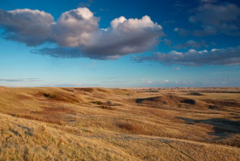
Saskatchewan’s Missouri Coteau grasslands, pothole wetlands, lakes, streams, and riparian environments provide crucial habitat for a variety of plants and animals. The area is internationally recognized as one of the most productive areas for waterfowl in the Prairie Pothole region. Three of the lakes in the Missouri Coteau have been collectively identified as a hemispherically significant site by the Western Hemisphere Shorebird Reserve Network.
Missouri Coteau, Saskatchewan (Photo by Branimir Gjetvaj) Source: https://bit.ly/2stud2y
The Prairie Habitat Joint Venture, a partnership between the provinces of Alberta, Saskatchewan, Manitoba, the Government of Canada, and non-government conservation organizations, including Ducks Unlimited Canada and the Nature Conservancy of Canada, has conserved habitat by means of more than 400 projects in the Missouri Coteau with help through the North American Wetland Conservation Act.
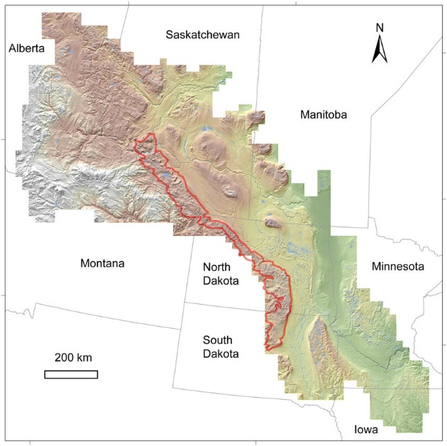
The Missouri Coteau region extends from southern Saskatchewan, Canada to South Dakota, U.S. The landscape in the Coteau has a knob and kettle landscape, which means there are numerous hills and ponds. According to the Nature Conservancy of Canada’s Cameron Wood, the hilly, pothole-filled landscape has hindered agricultural development, which means the land has largely been left intact as grasslands. This has benefited the waterfowl and shorebirds that feed and breed there.
“During the spring and fall migration seasons, the density of waterfowl and shorebirds is astounding,” Wood says. “The Missouri Coteau is the center of the hourglass in terms of North American bird migrations.” For example, northern pintail ducks

Map of the Prairie Pothole Region of the United States and Canada (colored area) and the Missouri Coteau (red outline). Modified from Liu and Schwartz (2012). Source: https://bit.ly/35uxvBg

use the Coteau for breeding and migration. Pintail’s winter habitat in the southern U.S. and Mexico.
Dozens of bird species funnel into the Coteau during the shoulder seasons and continue their migrations north or south expanding across the range of the continent. About a dozen duck species and many grassland species spend their breeding seasons nestled among the potholes of the nearly pristine prairie landscape.
Nature Conservancy of Canada has worked to conserve more than 11,000 acres of wetlands and 57,000 acres of associated upland habitat. The focus of the series of projects was long-term conservation of private land that may have been at risk of conversion to cultivated agriculture or oil and gas development. Land was protected largely through conservation easements, which means landowners were compensated for putting their land in a perpetual state of conservation. The land cannot be developed even if it switches owners.
The conserved land requires long-term management, yearly monitoring, and habitat restoration and enhancement. “In addition to making sure it exists, our goal is to maintain or improve the quality of the habitat on conserved land,” Wood says.
“It has become incredibly rare to see landscapes how they looked 200 years ago,” Wood explains. “The fact that people can see large tracts of native prairie with native wetlands is unique and important. In addition, this area is significant for Indigenous cultures.”
Nature Conservancy of Canada’s conservation work in the Missouri Coteau was supported by grants from the North American Wetlands Conservation Act (NAWCA), which has provided funding for wetland habitat preservation projects in the U.S., Canada, and Mexico since 1989.
Over the past 30 years, NAWCA has grown into one of the most significant conservation programs in history. More than 3,000 NAWCA-funded projects have conserved 30 million acres of wetlands and related habitats, which combined makes up an area the size of Pennsylvania. The projects span nearly every state, territory, and province in Canada, the U.S., and Mexico.
The goal of the multi-billion dollar grant program is to guarantee waterfowl and other wetland-dependant species success across the continent, from breeding to wintering grounds, in perpetuity. Many of the projects have improved birdwatching, hunting, fishing, and other outdoor recreation opportunities on public lands.
Habitats conserved through NAWCA projects have far reaching impacts. For example, the conserved wetlands store water and recharge aquifers, which helps secure future water supplies. Healthy wetlands also improve water quality by removing phosphates, nitrogen, and pesticides. When wetlands are restored to their natural states, they help prevent soil erosion during floods.
“NAWCA funding has been critical for our series of projects in the Missouri Coteau,” Wood says. “In the future, I would like to see conservationists broaden their focus by looking at wetlands holistically, beyond just their potential for waterfowl, to include their benefits for water quality and quantity management. Looking at wetlands within a broader context of connected landscapes and habitats is important.”
While the outlaw era has faded into history, the birds and animals that inhabit the Missouri Coteau will continue to find refuge in this unique landscape.

