Rare Birds’ Wetland Habitat Restored
Golden-winged warblers in southern New York State maintain their genetic integrity thanks to habitat enhancement projects

By Jessica Shea

Bee-buzz-buzz

Only the most discerning birders’ ears can suss out the rare golden-winged warblers’ song while walking in the wetlands of Harriman and Sterling Forest State Parks in New York. Golden-winged warblers and their elusive melody were in danger of disappearing from their southern New York State breeding grounds. Habitat enhancement, funded in part by a grant through the North American Wetlands Conservation Act, is helping to ensure the species’ continued success.

Sporting their namesake wings and distinct yellow cap with black mask, golden-winged warblers are about the size of a small apple. Weighing in at only a third of an ounce, however, these diminutive birds are true featherweights. The migrating songbirds winter in Central and South America. Come spring, they fly north along the Eastern seaboard, nesting along the way from the Virginias to the mid-Atlantic, the Upper Midwest, the Northeast, and Canada. The majority of the warbler population settles in the Great Lakes region of the United States and Canada.

“The Hudson Highlands is a forested and lake-filled area of southern New York State surrounding the Hudson River that has long supported populations of nesting golden-winged warblers,” explains Matthew Shook, director of development at the Palisades Interstate Park Commission.

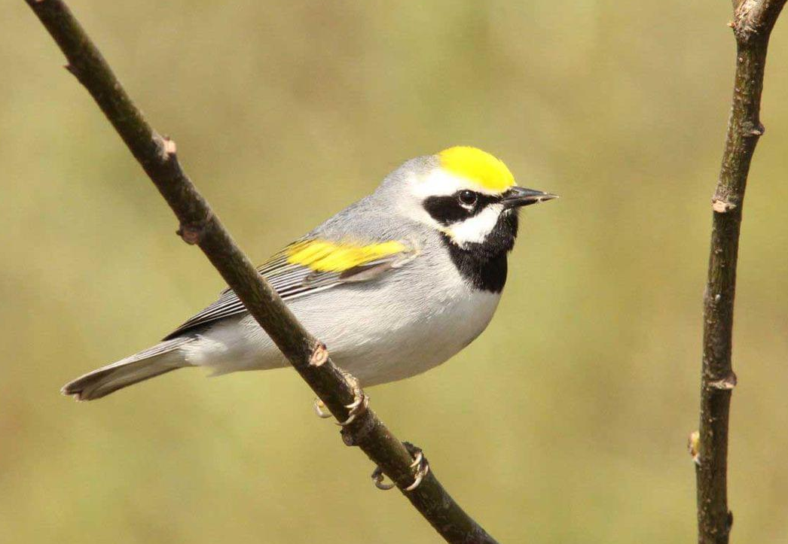
Golden-winged warblers preferred wetland nesting habitat in Harriman and Sterling Forest State Parks was threatened by invasive phragmites and red maple encroachment, afflictions that sound as menacing as horrors from a science fiction film. Invasive phragmites are non-native common reeds that take over wetlands. Common reeds can grow as tall as a two-story house and hedge out golden-winged warblers’ favorite nesting sites: cattails and sedge, a wispy grass-like plant that grows in clumps.
Golden-winged warbler. Photo by Caleb Putnam, CC BY-SA 2.0.

Similarly, harmful to golden-winged warbler habitat is red maple encroachment, which happens when maple trees creep onto the periphery of wetlands. Tree by slow-growing tree, they mature and their expansive crowns shade the wetlands and limit the sunlight reaching sedge, decreasing its ability to grow.

Golden-winged warblers’ vulnerability doesn’t stop with habitat change. The real threat comes in the form of their cousins, blue-winged warblers. Blue-winged warblers can better handle nesting in areas near development, while their golden counterparts prefer undeveloped wetlands. “When development encroaches on wetlands and habitat is altered through invasive reeds and shade-giving red maples,” says Shook. “blue-winged warblers move in and interbreed with goldens.”

Like natural redheads in the human population, golden-winged warblers distinctive coloring is being overshadowed by dominant genes, in this case from blue-winged warblers. Not only does golden-winged warblers’ distinctive coloring alter after interbreeding with blue-hued cousins, but their song changes too.

The Palisades Interstate Parks Commission worked to preserve golden-winged warblers genetic integrity, and thus their appearance and song. First, they performed field surveys to determine the existing warbler population. Field biologists went into wetlands during nesting season and played a recording of a male golden-winged warbler’s song. The male warblers in the area flew in to check out what they thought was a new male on their turf, which allowed biologists to get a count on birds in the area.

Sometimes field biologists played a recording of a screech owl. Since screech owls prey on warblers, warblers are known to mob the birds. Shortly after playing the recording, biologists were surrounded by upwards of 50 small agitated birds. “It felt eerie, like a scene from an Alfred Hitchcock movie,” Shook says.

The next step in improving golden-winged warbler habitat was herbicidal and mechanical treatment to remove all common reeds. Conservationists also thinned red maples to create beneficial canopy gaps. “There tends to be some controversy when habitat restoration involves the use of an herbicide, but we were deliberate and conservative in our use of it. We also worked with a league of local volunteers and partnered with the local Audubon chapter to involve the local community,” Shook explains. “The habitat diversity that has been created through this work will be sustained for a long time, and more diverse habitats are more resilient.”

The habitat preservation work at Harriman and Sterling Forest State Parks in New York received a grant from the North American Wetlands Conservation Act (NAWCA), which has provided funding for wetland habitat preservation projects in the U.S., Canada, and Mexico since 1989. The NAWCA-funded golden-winged warbler breeding ground work is part of a larger effort to manage and preserve habitat throughout the life cycle of the warbler.

Over the past 30 years, NAWCA has grown into one of the most significant conservation programs in history. More than 3,000 NAWCA-funded projects have conserved 30 million acres of wetlands and related habitats, which combined makes up an area the size of Pennsylvania. The projects span nearly every state, territory, and province in Canada, the U.S., and Mexico.

The goal of the multi-billion-dollar grant program is to guarantee waterfowl and other wetland-dependent species success across the continent, from breeding to wintering grounds, in perpetuity. Many of the projects have improved birdwatching, hunting, fishing, and other outdoor recreation opportunities on public lands. Habitats conserved through NAWCA projects have far reaching impacts. For example, the conserved wetlands store water and recharge aquifers, which helps secure future water supplies. Healthy wetlands also improve water quality by removing phosphates, nitrogen, and pesticides. When wetlands are restored to their natural states, they help prevent soil erosion during floods.

“Ultimately, the goal is to ensure that wetland habitats are sustained for all the species that inhabit them,” Shook says. “People should have the opportunity to experience nature as it would have been if we had not brought invasive plants, polluted the air and water, and cut down trees. Our goal is to manage habitat so it can be as natural as possible.”

The restoration work at Harriman and Sterling Forest State Parks have ensured a place for people to see and hear golden-winged warblers and experience wetlands in their natural state. The unique trill of golden-winged warblers will fill the wetlands for years to come.

