Wetlands Restored at the Confluence of America’s Mightiest Rivers
Thousands of hunters and birdwatchers enjoy one of the most important regions for waterfowl in the midcontinent of the United States

By Jessica Shea

Raised on a farm in Central Missouri, Mark Flaspohler grew up exploring the big river floodplains. Flaspohler comes from a long line of conservationists and hunters; he began the family tradition of duck hunting at 10 years old. Through hunting and spending time in nature, Flaspohler developed a love of the land that as an adult led him to his job of 14 years as a biologist with Ducks Unlimited. Flaspohler and partners have shepherded a series of grants from the North American Wetlands Conservation Act to protect, restore, and enhance thousands of acres of wetlands in the Confluence Region of eastern Missouri.
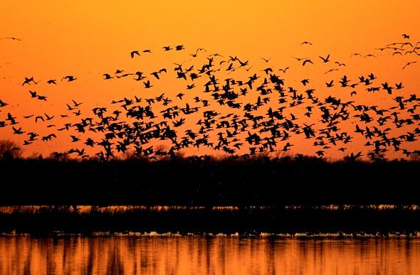
The Confluence Region is the area surrounding the merging point of the Missouri and Mississippi rivers. The region often floods in the spring due to snowmelt and significant rainfall upstream. This cyclical flooding has created the lush wetlands that have attracted millions of birds a year for centuries. More than 250 species of waterfowl, waterbirds, and neotropical songbirds migrate through or use Confluence wetlands, Flaspohler says.
Waterfowl at dusk over wetlands. Photo: Missouri Department of Conservation
The area teems with such an abundance of life that upon traversing the area in 1721, French explorer Father Pierre François de Charlevoix wrote: “I believe this is the finest confluence in the world.” The cultural, historical, and recreational significance of the Confluence dates back centuries.

However, in recent decades the area has lost 90 percent of its wetland habitats. Two challenges facing wetlands in the Big River Confluence Region are floodplain development and converting land to other uses. Floodplain development alters the ecosystem of the area. The sprawling urban population of St. Louis has been using the floodplain as an expansion zone for factories, homes, airports, and shopping malls. “Infrastructure built in this area needs levy systems to protect it when the water level increases during spring floods,” Flaspohler explains. “These levy systems cut off the natural flow of highwater events from their natural floodplains and adjacent wetlands.”

The natural ebb and flow of water in the wetlands has created rich soil. Thus, the fertility that allowed the Big River floodplains to become hotspots of natural biodiversity has led to their degradation at the hands of humans. Much of the wetland habitat has been drained for agricultural use, which is also important but has displaced native plants and animals. There are nearly 300,000 acres of floodplain agriculture in the Confluence Region.

Flaspohler and numerous conservation partners have been working for years to protect, restore, and enhance wetlands and associated habitats in the Confluence. Much of the work has been concentrated on three counties in northeastern Missouri: St. Charles, Pike, and Lincoln. In these three floodplain counties there are 60,000 acres of privately owned and managed wetlands. The wetlands are owned by duck clubs, some of which date back to the mid 1800s. This makes the Confluence Region one of the most important privately-owned wetland complexes in the United States. The private clubs in the Confluence often provide the last line of defense against the threat of land use conversion and urban development in the area.

A big part of the series of projects Flaspohler undertook in the Confluence Region relied on the relationships he has developed with Duck Club owners and partners. He helped Ducks Unlimited put perpetual conservation easements on 10,000 acres of wetlands and associated habitats, which generated millions of dollars in conservation easement value. In turn, money went toward restoration and enhancement work of wetlands on public land. “We’ve created a private/public conservation partnership that is working well,” Flaspholer says.

To complete the series of Confluence projects, Flaspohler applied for grants from the North American Wetlands Conservation Act (NAWCA), which has provided funding for wetland habitat preservation projects in the U.S., Canada, and Mexico since 1989.

Over the past 30 years, NAWCA has grown into one of the most significant conservation programs in history. More than 3,000 NAWCA-funded projects have conserved 30 million acres of wetlands and related habitats. The projects span nearly every state, territory, and province in Canada, the U.S., and Mexico. The goal of the multi-billion dollar grant program is to guarantee waterfowl and other wetland-dependant species success across the continent, from breeding to wintering grounds, in perpetuity.

“The Missouri Department of Conservation, the U.S. Fish and Wildlife Service, and other conservation partners have created a great role model when it comes to conservation delivery,” Flaspohler says. “Though we have lost 70 to 90 percent of historic wetlands in Missouri, we’re moving in the right direction.”

The Confluence projects have provided habitat for waterfowl and other animals to thrive in the Big River floodplains and ensure that the thousands of hunters, birdwatchers, and outdoor recreationists who visit there annually will continue to enjoy the benefits of healthy wetlands.

