Wetlands and Forests Managed with Controlled Burns
Habitat Management gets creative in northwestern New Jersey

By Jessica Shea

Despite being nicknamed the Garden State, New Jersey is not generally renowned for its natural spaces. Sandwiched between New York City and Philadelphia, New Jersey is slated to become the first state to reach complete build out, anticipated by 2050. This means the use of every acre in NJ will be accounted for, ranging from protected farmland and natural spaces to residential, commercial, and industrial development. Currently, about 40 percent of land cover is forests.

In northwestern NJ, about 860,000 acres are recognized as the New Jersey Highlands and is governed by an agency to help with regional planning and development. The New Jersey Audubon Society, with support from the North American Wetland Conservation Act (NAWCA), is working with a Highlands’ landowner to help manage one of the largest privately held nature properties in the state.
The highlands region of northwestern New Jersey has wetlands and neighboring upland forests. The highlands are home to bird species of concern such as American black duck and the state endangered golden-winged warbler. Golden-winged warbler, for example, has lost 75 percent of its population in New Jersey since the 1990’s.
Golden-winged warbler. Photo: USFWS

While other species have declined at similarly staggering rates, the reasons for these declines vary from loss of habitat to development, fragmentation, impacts on the forest by overabundant deer populations, and disruption from non-native invasive plants and pests. The forest in northwestern NJ was cleared approximately 100 years ago for human use. Those forested lands grew back, but most of the regrowth was similar in age, resulting in a lack of diversity and providing poor-quality habitat for species like golden-winged warblers.

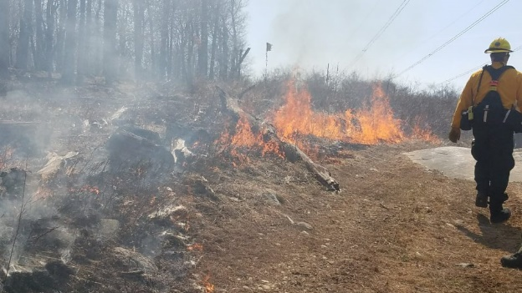
One way to improve the habitat quality of these forests is by mimicking natural processes, like fire. Research shows that natural wildfires were part of the landscape in northern New Jersey far before European settlement. Northern NJ’s oak-hickory forests in particular adapted to the presence of fire, which helped maintain species richness and structural diversity in the forest by creating canopy gaps, thus allowing important tree species to grow more easily.
Controlled burn in New Jersey oak forest. Photo: New Jersey Audubon.

Since fire suppression has been so effective in New Jersey during the last century, the absence of natural fires in forest ecosystems has contributed to declines in wildlife and uniformity of plant life in the forest. In the New Jersey highlands, controlled burns have not been a common method of habitat management in the past several decades. However, properly used prescribed burning in oak-hickory forests can help these forests more closely resemble a natural state.

“It’s important to recognize to interfaces between ecosystems,” says NJ Audubon’s stewardship project coordinator Ryan Hasko. For example, forest ecosystems are fundamental for supplying water to adjacent wetlands. “We recognized that the same species are using adjacent forests and wetlands, and we received a NAWCA grant in recognition of our proposal taking a holistic look at different habitats on the ground. NAWCA funding allowed us to experiment with using a creative solution for habitat management.”

“Using controlled burns in a wetland might sound funny to people,” says Hasko, “but burning in an area where the soil is high in moisture allows us to target and eliminate aggressive invasive ground species of plants without the use of herbicides.” This will ideally create gaps in the forest for new native plants to thrive.

According to John Cecil, NJ Audubon’s vice president of stewardship, “The public tends to have a knee-jerk reaction to burning trees and plants, even at the benefit of the habitat. It’s an interesting catch-22. The public doesn’t have a lot of exposure to positive habitat manipulation.” For example, air quality degraded by vehicle emissions gets tangled in the public’s mind with smoke from burning, which leads to a negative perception of prescribed fire.

New Jersey Audubon would like to increase the public’s awareness of fire as a habitat management tool. The organization found a unique opportunity to expose the public to the benefits of burning. NJ Audubon partnered with the Hudson Farm Club, whose land, managed under a Forest Stewardship Plan, presents a unique opportunity to test stewardship and habitat management approaches.

“The hunting club prides itself on being a model of ecological stewardship,” explains Hasko. At 4,000 acres, the club is the largest privately owned property in northwestern New Jersey’s Sussex County. “Our aim is to report the results of the prescribed burns and get conversations started in the public and with other conservation organizations and agencies.”

New Jersey Audubon received support for habitat management using prescribed burns from the U.S. Fish and Wildlife Service’s North American Wetland Conservation Act. NAWCA has provided funding for wetland habitat preservation projects across North America since 1989. Over the past 30 years, NAWCA has grown into one of the most significant conservation programs in history. More than 3,000 NAWCA-supported projects have conserved 30 million acres of wetlands and related habitats. The projects span nearly every state, territory, and province in Canada, the U.S., and Mexico. The goal of the multi-billion dollar grant program is to guarantee waterfowl and other wetland-dependant species a diversity of habitats across the continent, from breeding to wintering grounds, in perpetuity.

Habitats conserved through NAWCA projects have far reaching impacts. NAWCA-funded projects across Canada, the U.S., and Mexico have improved birdwatching, hunting, fishing, and other outdoor recreation opportunities on public lands. For example, the conserved wetlands store water and recharge aquifers, which helps secure future water supplies. Healthy wetlands also improve water quality by removing phosphates, nitrogen, and pesticides. When wetlands are restored to their natural states, they help prevent soil erosion during floods.

According to Cecil, during the past 30 years data show that many waterfowl populations have stabilized or increased thanks to the emphasis on wetland conservation through programs like NAWCA. However, the same has not been true for grassland and forest birds.

“I would love to see our forests functioning in a more natural way,” says Cecil. “Ideally, forests will come back in the same way wetlands have during the past few decades. To get there we first need a human population that is willing to see habitat manipulated and managed. The question then becomes, how do we do a better job of engaging and educating the public about different types of habitat management techniques? Ultimately, we need to get the public onboard.”

