Waterfowl Habitat Created from Former Catfish Farm
Seasonally managed wetlands teem with birds in the Mississippi Delta

By Jessica Shea

Houston Havens grew up in Mississippi hunting and fishing near the state’s namesake river delta. “I knew early on that I wanted to be a wildlife biologist,” says Havens. During his studies he met mentors who helped narrow his focus to waterfowl biology. After five years as a waterfowl program coordinator for the Mississippi Department of Wildlife, Fisheries, and Parks, Havens has recently completed one of the longest-term and most significant projects of his career.

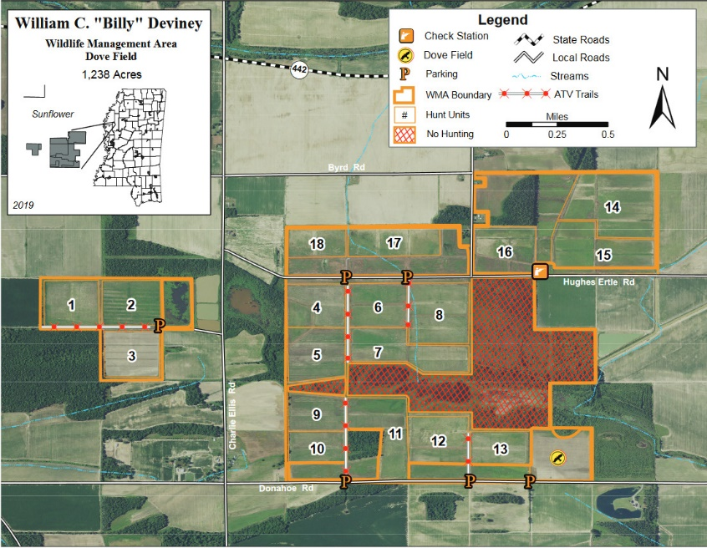
The nearly 1,000 acres that became the William C. “Billy” Deviney Wildlife Management Area spent years as an aquaculture farm. The square high-walled levy ponds on the farm were ideal for raising catfish but were poorly suited habitat for migratory birds. When the state of Mississippi acquired the land, significant work was needed to restore the wetlands for use by waterfowl, geese, and shorebirds.

According to Havens, there is not a lot of managed waterfowl habitat across the landscape in Mississippi during some important times of the year for migratory birds. “The Deviney Wildlife Management Area fulfills the need for managed wetland habitat, which is especially important for migratory birds in early fall and early spring,” says Havens.
Photo: Mississippi Wildlife, Fisheries, & Parks

To make the wetlands bird-ready, the Mississippi Department of Wildlife, Fisheries, and Parks and partner organizations had to do a lot of work on the ground, moving dirt so the steep-banked catfish farming ponds were transformed into gently sloping shallow ponds, explains Havens. The ponds have underground piping that brings water in during fall and drainage structures to remove water in the springtime.

In 2015, the first fall after the project was complete, Havens got a call that he has remembered for years. “I was told the first ducks were spotted in the wetlands,” says Havens. “I remember my excitement hearing there were birds using the area as intended. It felt gratifying to see a project three years in the making succeed.”

Currently, several thousand waterfowl winter in the seasonal wetland habitat every year. The public has the opportunity to observe wildlife on managed wildlife habitat. People come from all over Mississippi and other states to birdwatch and hunt, says Havens. In early fall, visitors can spot waterfowl, like blue-winged teal, and shore birds, like sandpiper, black-necked stilt, ibis, and egret. Peak abundance of waterfowl is January, when the area is alive with dabbling and diving ducks along with geese.

The William C. “Billy” Deviney Wildlife Management Area received support from the U.S. Fish and Wildlife Service’s North American Wetland Conservation Act. NAWCA has provided funding for wetland habitat conservation projects across North America since 1989. Over the past 30 years, NAWCA has grown into one of the most significant conservation programs in history. More than 3,000 NAWCA-supported projects have conserved 30 million acres of wetlands and related habitats. The projects span nearly every state, territory, and province in Canada, the U.S., and Mexico. The goal of the multi-billion dollar grant program is to guarantee waterfowl and other wetland-dependent species a diversity of habitats across the continent, from breeding to wintering grounds, in perpetuity.

Habitats conserved through NAWCA projects have far reaching impacts. NAWCA-funded projects across Canada, the U.S., and Mexico have improved birdwatching, hunting, fishing, and other outdoor recreation opportunities on public lands. For example, the conserved wetlands store water and recharge aquifers, which helps secure future water supplies. Healthy wetlands also improve water quality by removing phosphates, nitrogen, and pesticides. When wetlands are restored to their natural states, they help prevent soil erosion during floods.

“Without matching funds from NAWCA it would have been extremely difficult to pull off this project,” notes Havens. The Mississippi Department of Wildlife, Fisheries, and Parks used the federal dollars to match state funds and contributions from other organizations to complete the on-the-ground work for this project.

Havens says in the coming 30 years, he’d like to see greater protection for conservation funding because funding sources for conservation tend to be competitive and challenging to obtain. “I’d also like to continue to see increased interest from private landowners interested in conservation on their land.”

